**Caroline Case**

**Homework 6: Virtual Memory**

**Due date: 11:59PM Friday April 24**

1. Consider a computer with a paged logical address space with 8 pages and each page is 4 Kbytes. The logical address space is mapped into a 256-Kbyte of physical memory space. (30pts)
   1. 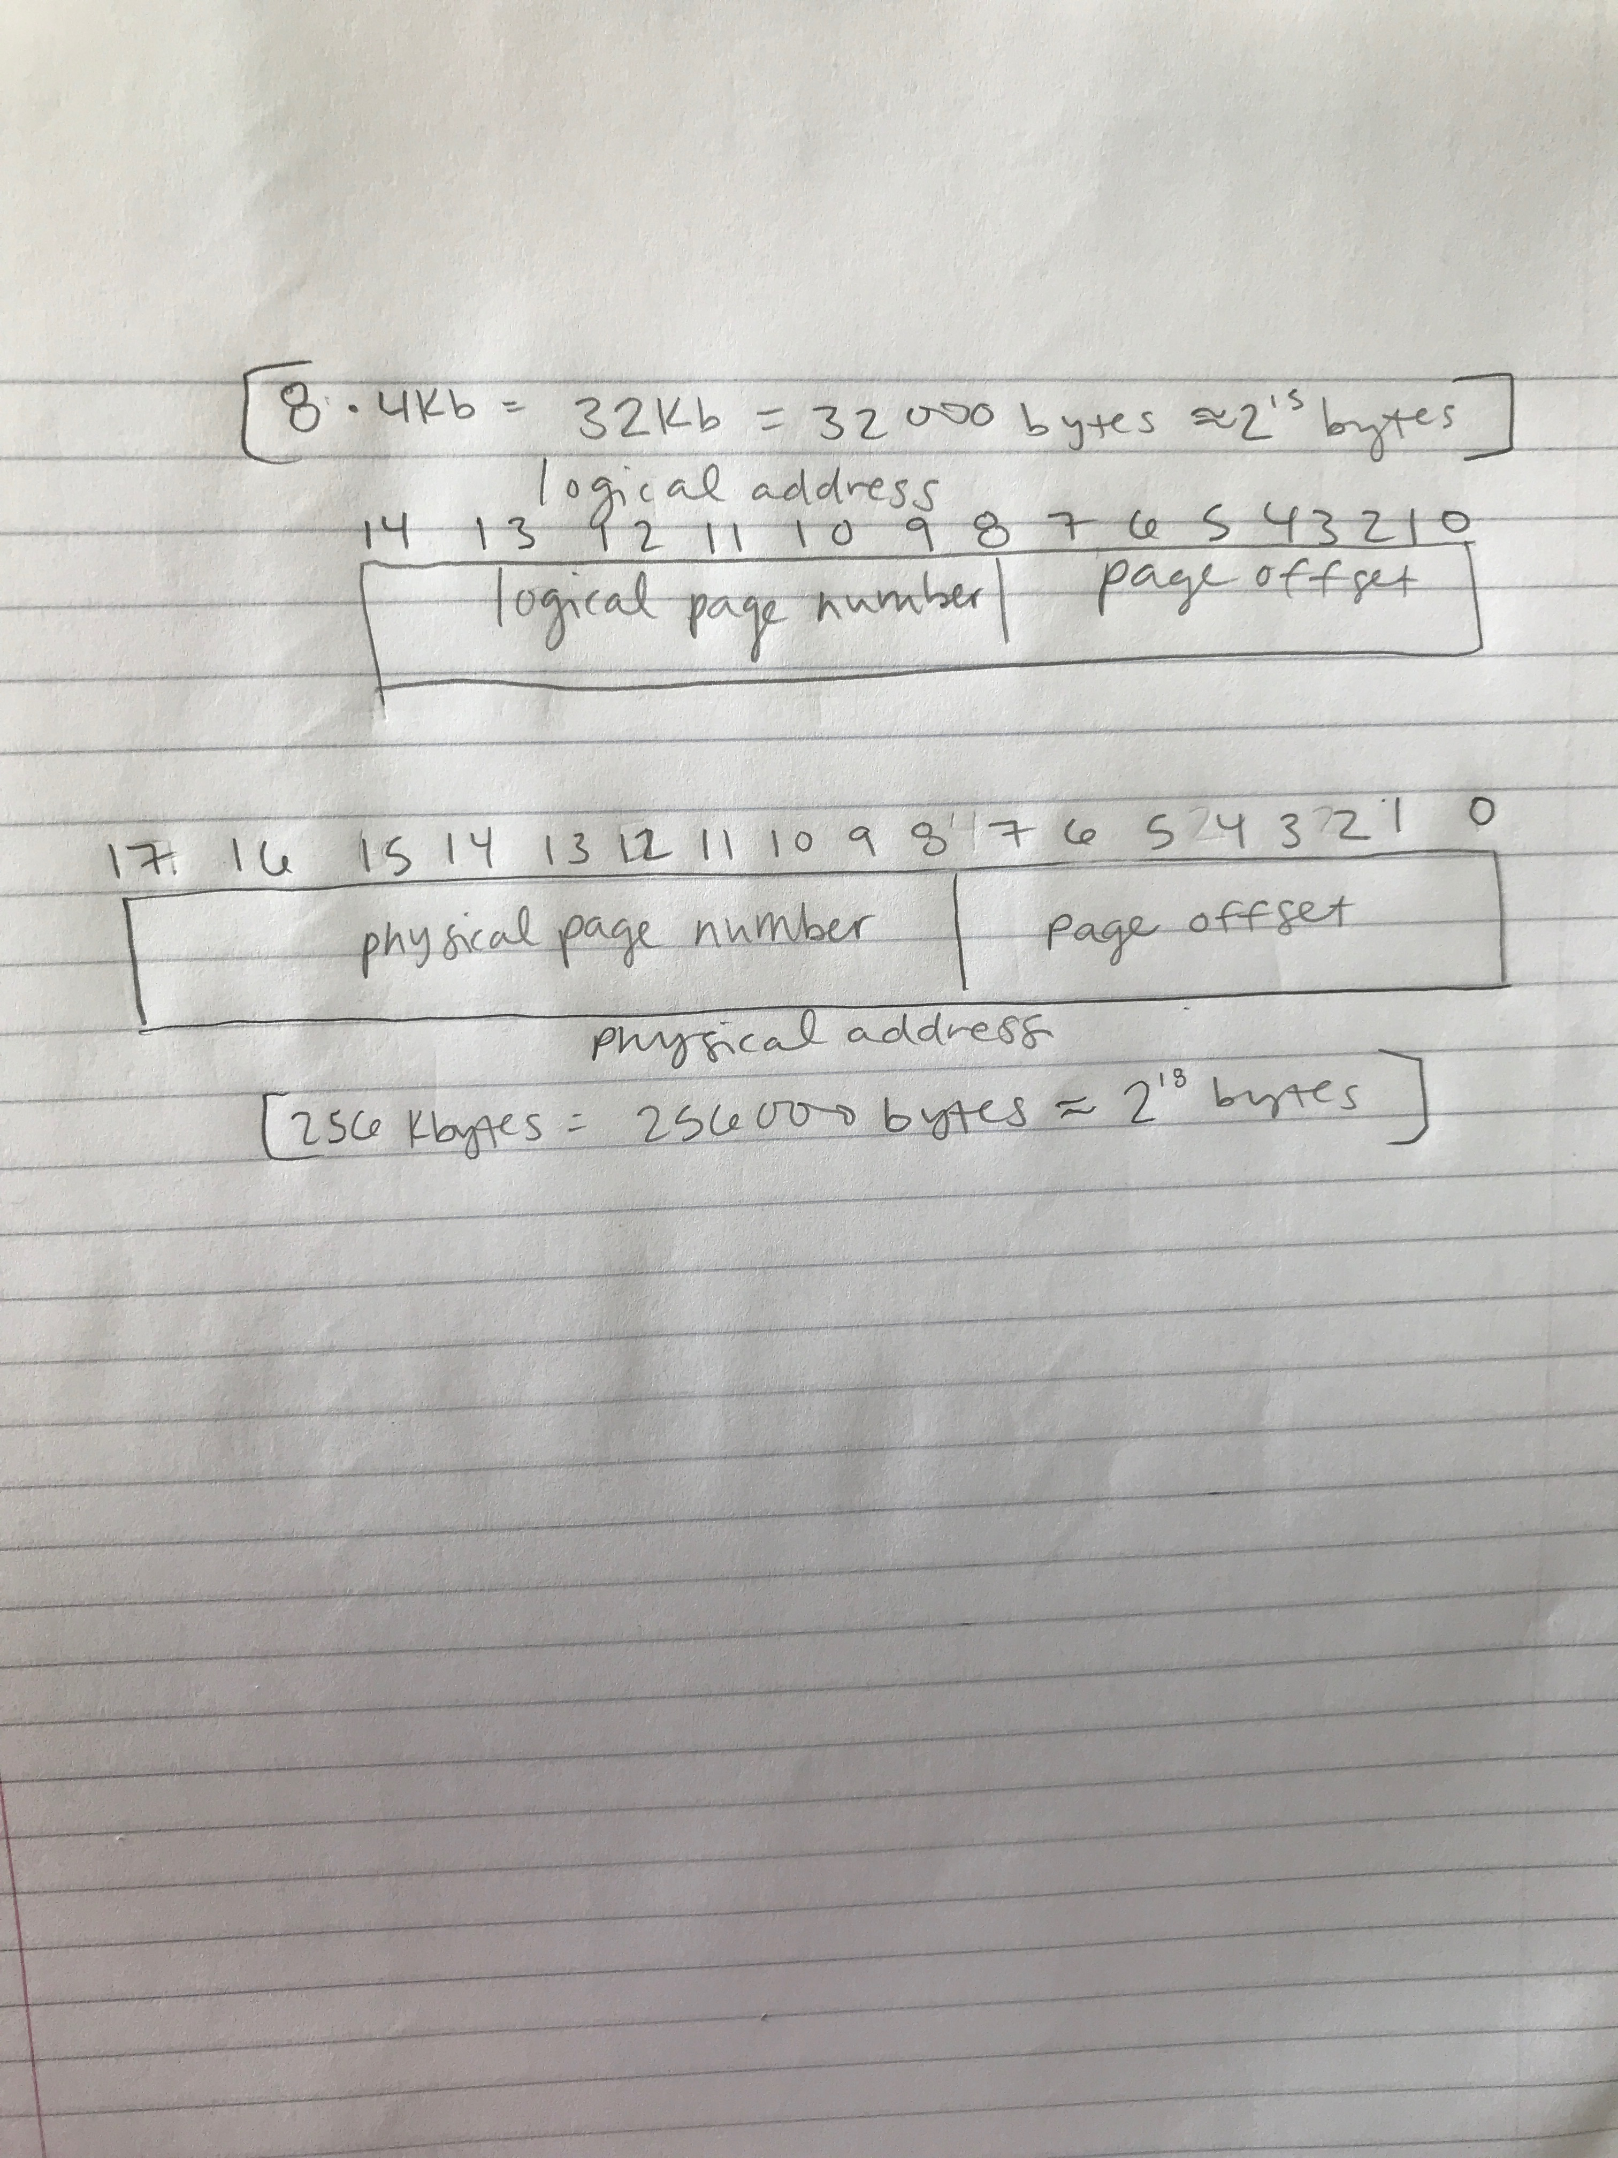Draw the fields in the logical and physical addresses and show the number of bits of each field.

* 1. 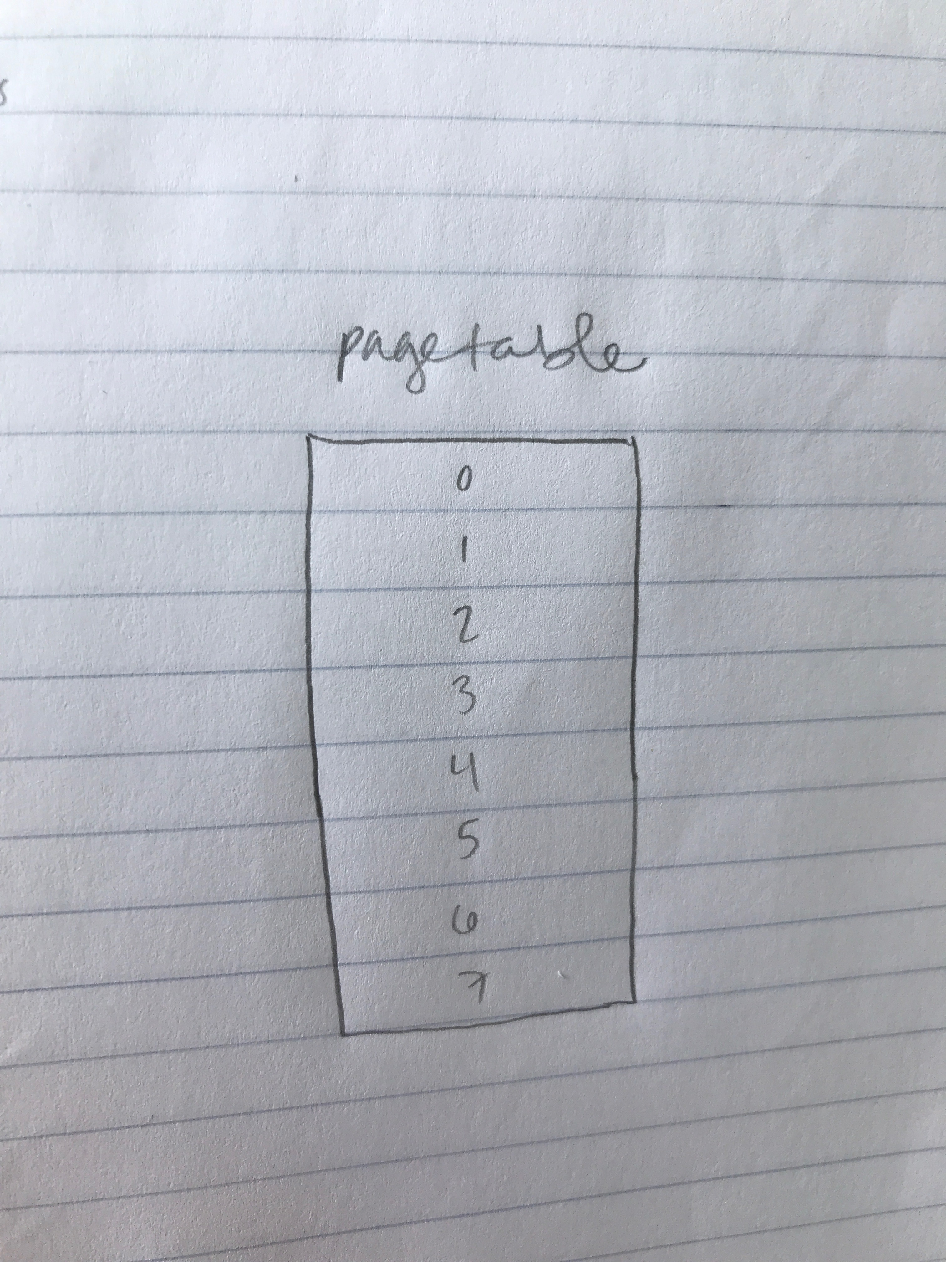Draw the page table of a process and show the number of entries in the table and number of bits per entry.

????????

* 1. Populate the page table for process, namely A, which is currently running on the CPU. Several pages of process A is in the physical memory as follows:

|  |  |
| --- | --- |
| #frame 00 | Page 3 of Process A |
| #frame 01 | Page 6 of Process A |
| #frame 02 | Page 1 of Process A |
| #frame 03 | Page 0 of Process A |
| #frame 04 | Page 2 of Process A |
| #frame 05 | Page 7 of Process A |
| #frame 06 | Page 4 of Process A |
| #frame 07 | Page 1 of Process A |
| #frame 08 | Page 5 of Process A |
| #frame 09 | Page 3 of Process A |
| #frame 10 | Page 5 of Process A |
| #frame 11 | Page 4 of Process A |
| #frame 12 | Page 0 of Process A |
| #frame 13 | Page 7 of Process A |
| #frame 14 | Page 6 of Process A |

1. Consider paged virtual memory systems. Assume a page size of 256 bytes (28), and that processes in this system can have a maximum virtual address space of 16K bytes (214). The system is currently configured with 8K (213) bytes of physical memory. (30pts)
   1. How many pages are in the virtual address space?

Virtual memory / page size = 214 / 28 = **64 pages**

* 1. How many page frames are in the physical address space?

Physical memory / page frame size = 213 / 28 = **32 page frames**

* 1. A user process generates the virtual address 12,345 (0011000000111001 in binary). Explain how the system establishes the corresponding physical address assuming that the hardware memory management unit and transfer lookaside buffer (TLB) is used.

The TLB has the most recently used page-table entries. When the virtual address is generated, its page number is presented to the TLB, and if it’s found in its entries, the frame number is retrieved and the physical address is formed. If it isn’t found in the TLB’s entries, the page number is used to index the process page table.

1. Consider a paged virtual memory system with a physical memory that can only contain 4 pages. Assume the execution of a program generates the following address trace

*a b c d d f b e b e*

where *a*, *b*, *c*, *d*, *e*, and *f* are the pages referenced and the page frames are initially empty. (40pts)

* 1. How many page faults occur with first-in-first-out Page Replacement?

|  |  |  |  |  |  |  |  |  |  |  |
| --- | --- | --- | --- | --- | --- | --- | --- | --- | --- | --- |
| *Time* | 1 2 | | 3 4 | | 5 6 | | 7 8 | | 9 10 | |
| *Request* | *a* | *b* | *c* | *d* | *d* | *f* | *b* | *e* | *b* | *e* |
|  | **a** | **a** | **a** | **a** | **a** | **b** | **b** | **c** | **d** | **d** |
|  |  | **b** | **b** | **b** | **b** | **c** | **c** | **d** | **f** | **f** |
|  |  |  | **c** | **c** | **c** | **d** | **d** | **f** | **e** | **e** |
|  |  |  |  | **d** | **d** | **f** | **f** | **e** | **b** | **b** |
| Fault? | **\*** | **\*** | **\*** | **\*** |  | **\*** |  | **\*** | **\*** |  |

**7 faults**

* 1. How many page faults occur with LRU Page Replacement?

|  |  |  |  |  |  |  |  |  |  |  |
| --- | --- | --- | --- | --- | --- | --- | --- | --- | --- | --- |
| *Time* | 1 2 | | 3 4 | | 5 6 | | 7 8 | | 9 10 | |
| *Request* | *a* | *b* | *c* | *d* | *d* | *f* | *b* | *e* | *b* | *e* |
|  | **a** | **a** | **a** | **a** | **a** | **b** | **c** | **d** | **d** | **d** |
|  |  | **b** | **b** | **b** | **b** | **c** | **d** | **f** | **f** | **f** |
|  |  |  | **c** | **c** | **c** | **d** | **f** | **b** | **e** | **b** |
|  |  |  |  | **d** | **d** | **f** | **b** | **e** | **b** | **e** |
| Fault? | **\*** | **\*** | **\*** | **\*** |  | **\*** | **\*** | **\*** | **\*** | **\*** |

**9 faults**